Sort by

Points about excel

Unnecessary columns and all u can hide

## All Functions

funcitons

=average(k2:k20)

1) to count how many are blank =COUNTBLANK(I2:I20) // or =COUNTBLANK(Table1[Benefits]).

2) like move from top to bottom Ctrl + >

### Sort

3) to sort click Data tab --> big sort button- with this u can sort by any column ascending or descending & u can add another column also

Or u can use small icons also in home tab

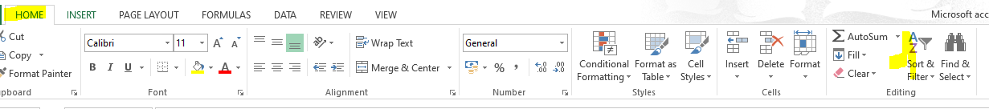

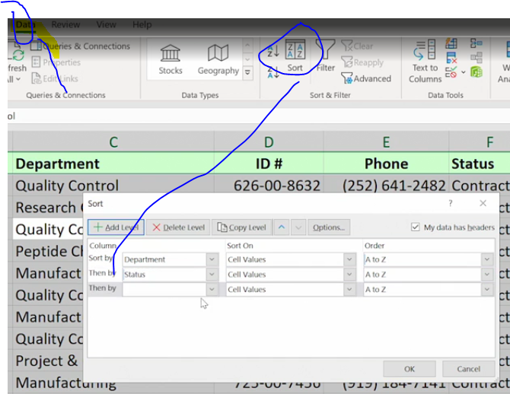

4) u can sort using custom type also, instead of ascending/ descending, u can write custom format and import

That format

|  |
| --- |
| Hourly |
| Full Time |
| Contract |

Select these and import in file🡪 options🡪 …..

5) u can sort by font color/cell color also

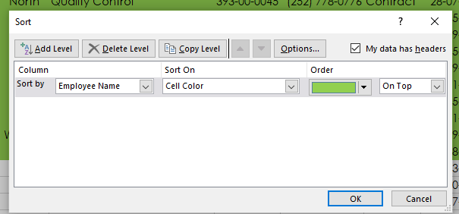

6) u can generate sub totals (Data🡪 sub total)

While generating subtotals make sure data is sorted

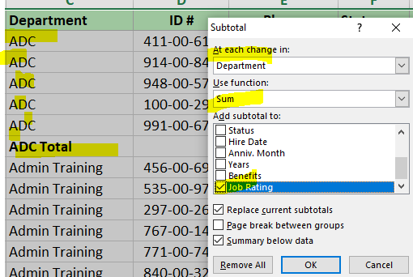

### Filter

Note:- after filtering only some data will be visible, whenever u copy only visible data will be copied

What ever u see only that will be copied

7) to filter u can type Ctrl+shift+L

Filtered data can also be sorted, u can clear all the filters at once also,

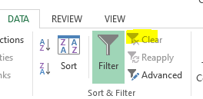

Note after filtering, u will see only some records, remaining and all will be hidden

So in this scenario, after hiding the data , if u copy or print then u will copy only the visible data



Adding auto filter shortcut to the excel

Ex:- if u have emp more than 10Y as well as less than 1 year, then u have to use OR condition

Problem with filtering multiple columns with or (in this case we have to choose advanced filters)

Lets say u have 2 columns, experience and sal

For AND operation(whose exp>15 and whose sal>1lakh) we can just simply apply filter on both columns but

If I want emps with either >15 or >1 lakh salary, if u filter both columns it will internally do AND operation

And it will fetch only employees who are 15+ and sal >1 lakh,

And we will loose all emps who are >15 but less that 1 lakh

#### **Filtering with OR condition on multiple columns**

Ex:- salary >1.oo,ooo or experience>15 or Status=hourly

If we want to filter all those records then we have to use advanced filter like below

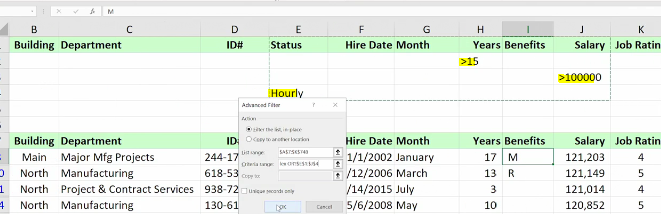

## Table

To convert excel sheet to table, use Ctrl+T

If u don’t want those column, u can just do right click and hide

Slicer

Slicer is also for filtering only, but visually it is easy to filter just we can select

Slicer is only applicable when sheet is converted to table (use Ctrl+T to convert to table)

Insert tab 🡪 click slicer



U can remove duplicates using DATA tab🡪 remove duplicates

Formulas

Goto formulas tab🡪

CountIF , sumif (count with criteria, sum with criteria)

Now we are counting based on this critieria

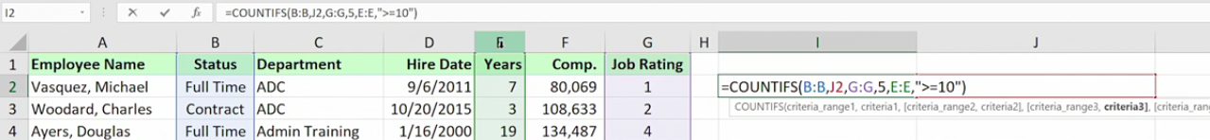

It says stautus B column is full time, job rating is 5, years is >=10

=COUNTIF(criteria,range)

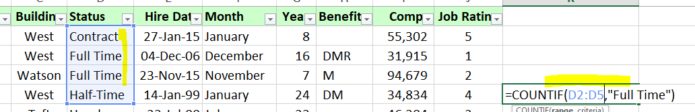



As from D2:D5 we got only 2 Full time records its showing count as 2